**Crime Trends Analysis in Boston (2018-2022)**

**Final Project: Proposal/Dataset Selection**

**ALY6015: Intermediate Analytics**

**College of Professional Studies – Northeastern University**

**By-Kaushal Girish Nagrecha**

**Srilekha Ganga**

**Xiao Hu**

**Project Title**

"Crime Trends in Boston Neighborhoods: A Comparative Analysis of Crime Rates by Neighborhood and Crime Type (2018-2022)"

**Dataset Selection**

This analysis examines Boston crime trends (2018-2022) across neighborhoods and crime types, assessing pandemic impacts. Findings reveal neighborhood-specific patterns, significant crime rate differences, and a 2020 crime decrease linked to COVID-19 restrictions.

**Research Questions**

This project aims to answer the following questions:

1. What types of crimes are most prevalent, and how do these vary by neighborhood and year?
2. How have crime rates changed over time in different Boston neighborhoods?
3. Did the pandemic significantly affect crime rates, with a notably lower rate in 2020 compared to 2018 and 2022?

**Outcome Variables**

Primary Outcome: Yearly crime rate for different neighborhoods.

Secondary Outcome: Frequency of specific crime types over the years.

**Feature Engineering**

Transformed continuous crime count data into yearly crime rates by neighborhood.

Generated categorical variables for crime types and neighborhoods for comparative analysis.

**Predictor Variables**

Selected predictor variables include:

Year of the crime (2018, 2020, 2022)

Neighborhood (e.g., Roxbury, Downtown & Charlestown)

Crime type (e.g., Property Crime, Violent Crime, Shooting)

Offense description

**Important Sub-Groups**

Comparison of crime trends by neighborhood (e.g., Brighton, Dorchester, Roxbury).

Analysis of crime trends over time (e.g., Property Crime vs. Violent Crime).

**Descriptive Statistics Tables**

Table 1: Summary statistics of crime rates across all neighborhoods.

Table 2: Comparison of crime rates by neighborhood and by year to observe variations in specific neighborhoods.

**Visualizations**

Figure 1: **Bar chart** of "**Crime Rate by Neighborhood and Year**" illustrate crime trends in each neighborhood across 2018, 2020, and 2022. For example, neighborhoods like Dorchester and Roxbury show high crime rates across all three years, whereas neighborhoods like Hyde Park and West Roxbury report comparatively lower rates. This visualization highlights which neighborhoods may require more attention in terms of crime prevention efforts.

Figure 2: **Bar chart** of "**Crime Rate by Crime Type and Year**" showing the distribution of different crime types across the years. Property crime remains the most prevalent type of crime, with a decreasing trend over time. This helps identify which types of crimes are declining or remaining constant, aiding in targeted crime reduction strategies.

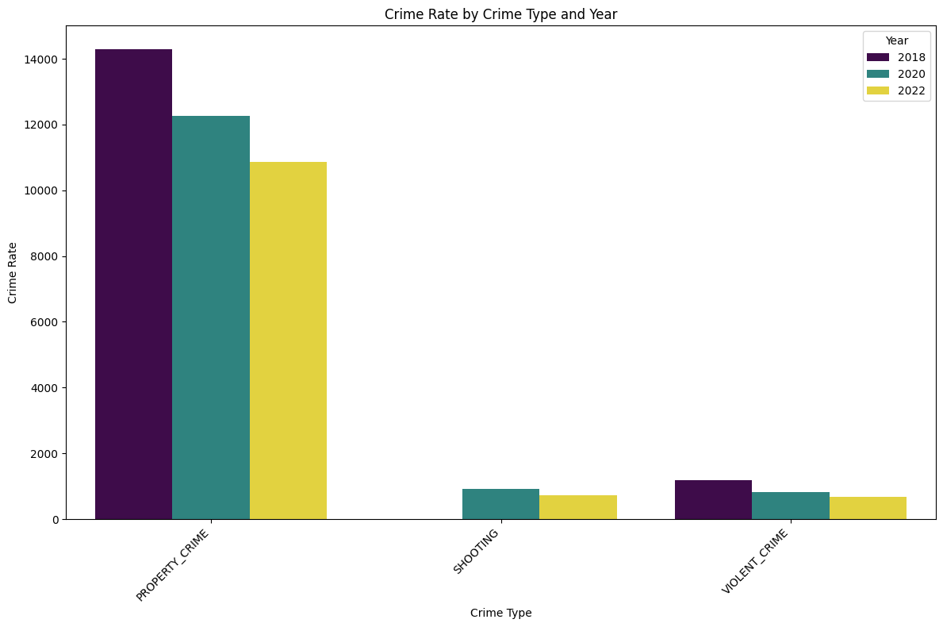

Figure3**: interactive Map** of Crime Trend Map of Boston Neighborhoods

An interactive map (created with Folium) visually represents neighborhood-specific crime trends and common crime types in Boston. For instance, Brighton and Dorchester display a downward trend in crime rates, especially in motor vehicle accidents​

**Analytical Plans and Methods**

The following analytical methods will be applied:

Method 1: Time Series Analysis to examine crime rate trends over the years across neighborhoods.

Method 2: Logistic Regression to predict high vs. low crime rate areas based on neighborhood and crime type.